Branching:

A great way to work on different versions of a project/file/repository. When we create a repository, we are, by default, creating only branch called “master”. We can create other branches and make edits to them and then can merge these to main branch “master”.

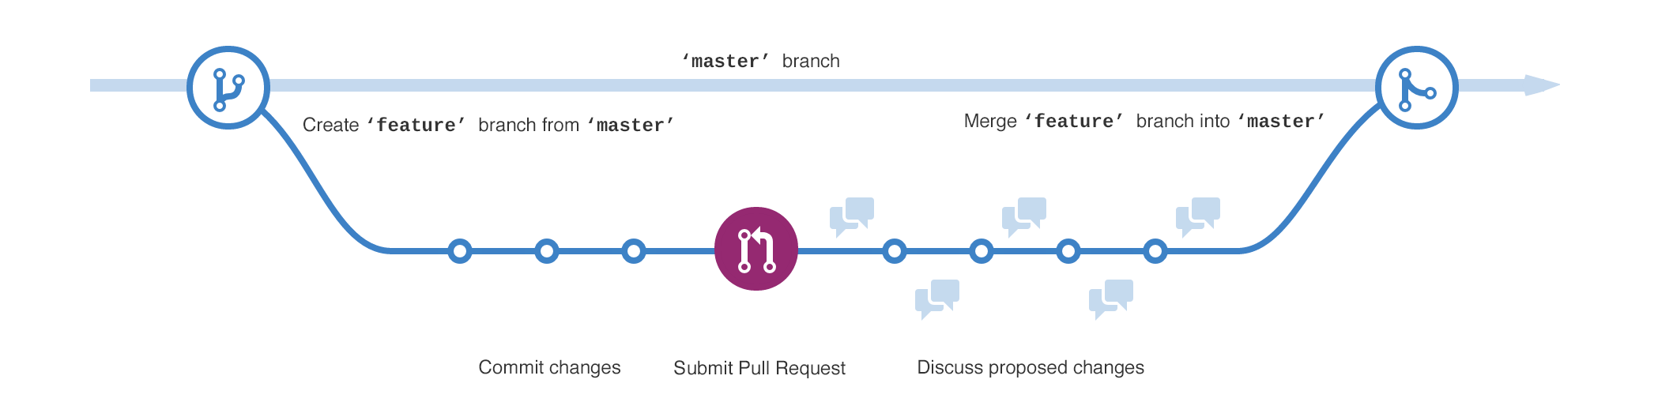

Pull Request:

Merge:

After reviewing and discussing the changes, these changes can be merged into master file. This will allow to add changes in our main file.